**Experiment Name :- HalfWaveSimpleDipole_1**

*Student Name :- Mr.Shirsh*

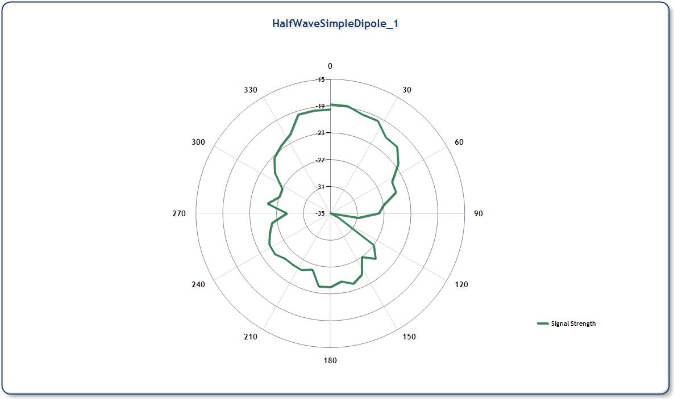

*signature of class teacher*